Naive Bayes algorithm is a classification technique that implemented by calculating the probability of certain unrelated events based on prior probabilities. For example, a fruit that is red, round, and about 3 inches in diameter will be considered as an apple. The reason why it is called “native” is that this algorithm assumed that all the events are independent, even it is hard to be true in the real world. But this assumption helped to solve sophisticated problems with more than one class counted. In metaphor, Naive Bayes prefer combination rather than permutation.

To start a Naive Bayes classification, construct a frequency table and a likelihood table that records the number of times that certain events happened in trials are usually the first two steps. They are two dimensions tables indicating the levels of features and levels of the class variables. please refer to the image down below. 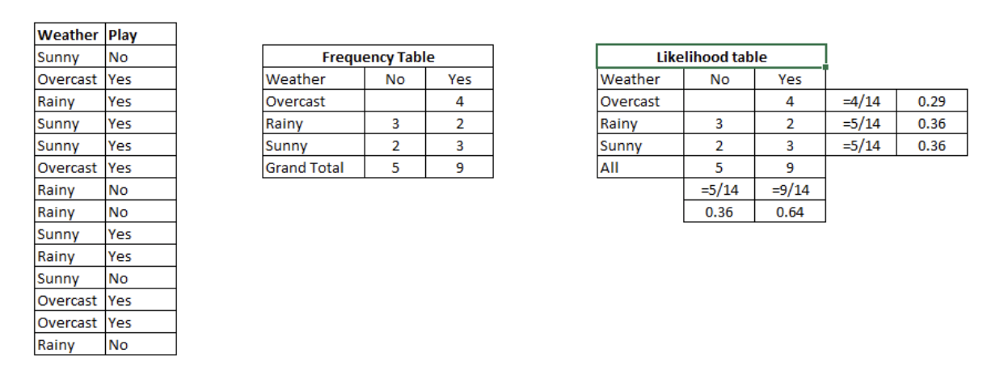
Then apply the Native Bayesian equation to calculate the posterior probability for each class. P(Yes | Sunny) = P( Sunny | Yes) * P(Yes) / P (Sunny), where P (Sunny |Yes) = 3/9 = 0.33, P(Sunny) = 5/14 = 0.36, P( Yes)= 9/14 = 0.64. So, the P(Yes | Sunny) = 0.60, which is higher then no probability.

One thing that needs to be mentioned is the Laplace estimator. It is useful when there is a 0 in one of the counts that leads to a 0-value likelihood. Laplace estimator solves the problem by adding a small number to each of the counts. Generally, the Laplace estimator is set to 1. Then there will be no 0 in the equation anymore.

Reference:
Lantz, B. (July 2015). Chapter 4: Probabilistic Learning – Classification Using Naïve Bayes. In Machine Learning with R (2nd ed., pp. 89-124). Birmingham, UK: Packt Publishing.

Ray, S. (September 11, 2017). 6 Easy Steps to Learn Naive Bayes Algorithm with codes in Python and R. Retrieved from: https://www.analyticsvidhya.com/blog/2017/09/naive-bayes-explained/

